Enhanced AASHTO Cumulative Difference Approach (CDA) for Pavement Data Segmentation

Samer W. Katicha
Group Leader, Structural Evaluation Group, Center for Sustainable and Resilient Infrastructure
Virginia Tech Transportation Institute
3500 Transportation Research Plaza, Blacksburg, VA 24061
Email: skaticha@vtti.vt.edu

Gerardo W. Flintsch
Dan Pletta Professor, The Charles E. Via Jr., Department of Civil & Environmental Engineering
Director, Center for Sustainable and Resilient Infrastructure, Virginia Tech Transportation Institute
3500 Transportation Research Plaza, Blacksburg, VA 24061
Email: gflintsch@vtti.vt.edu

Word count: 6,982 words text + 2 tables ×250 words (each) = 7,482 words

Submission Date: August 1, 2024

Abstract
This paper proposes improving the AASHTO cumulative difference approach (CDA) to pavement data segmentation. Although this approach is popular in pavement management applications, it is heuristic, based on visual inspection of plots of data, and has well-documented limitations. One main limitation is reliance on a change in sign of the slope of the cumulative sum of the data to identify segment breakpoints. This makes it very sensitive to small data variations (like noise), and researchers have shown that segment breakpoints can occur without a change in the sign of the slope. Our proposed approach uses the maximum (in absolute value) of the cumulative sum to identify a potential breakpoint. Whether that maximum is due to random variation or the presence of a true breakpoint is rigorously tested at a user-specified significance level using the known statistical distribution of that maximum. The approach also allows specifying a minimum segment length and minimum difference between adjacent segments. Simulation studies show that when the process that generated the data consists of piecewise constant segments, the Type I error of erroneously identifying breakpoints is controlled at the chosen statistical significance level, both for normally distributed random variation in the data and any distribution with well-defined variance. When the process that generated the data does not consist of piecewise constant segments, the approach results in a segmentation with a very low mean square error or mean absolute error with respect to the data generating process. We show an application to traffic speed deflectometer deflection data.
Keywords: AASHTO Cumulative Difference Approach, Pavement Management, Traffic Speed Deflectometer, Pavement Data Segmentation

Introduction
Segmentation of data collected on the road network is critical to pre-analysis in pavement management. The collected data can be pavement surface condition data, pavement deflection data, number of vehicle crashes per road section, or other quantities of interest. By far, the best known segmentation approach is the AASHTO cumulative difference approach (CDA) (1), which is based on what statistical literature refers to as the CUMSUM (cumulative sum) approach proposed by Page (2). While simple, the CDA has many drawbacks that make it hard to implement in a software (3-9). Many researchers have proposed modifications to the CDA to make it more computationally sound, but despite these efforts, the approach is still mostly used heuristically, based on visual inspection of plots. Therefore, other alternative methods for data segmentation have been proposed. Although these alternatives are generally statistically sound, they have not gained widespread use in the pavement engineering community. Early on, the main drawback of these methods was their computational complexity. However, even after significant advances in computational speed, these methods have still not gained wide acceptance. We believe that the reluctance to embrace these methods stems from their inability to replicate the intuitive results that engineers achieve through the traditional, visually driven AASHTO CDA. In this context, the concept of uniformity is defined more by engineering criteria than by statistical ones. Pavement managers aim to divide roads into sections that are uniform from an engineering perspective, not necessarily uniform statistically. This approach is underscored by the practice of categorizing road data—which is often not statistically uniform—into uniform sections for management purposes.
Statistical uniformity is clearly defined within a specific context; however, engineering uniformity is more ambiguous. For instance, statistical uniformity may consider a response to be piecewise constant, employing statistical change-point detection to identify shifts in the mean response. However, in scenarios where the response is not piecewise constant, the need to segment data into uniform sections for management purposes persists, highlighting the relevance of engineering uniformity. Consider an example involving a sinusoidal process with noisy measurements as shown in Figure 1. Statistical segmentation works to closely approximate the actual process, leading to numerous piecewise constant segments, as depicted in the bottom left panel of Figure 1. This segmentation minimizes the mean square error (MSE) against the actual sinusoidal signal, yet it may not align with the engineering goal of defining uniform sections. From an engineering standpoint, a preferable segmentation might resemble the one shown in the bottom right panel of Figure 1, where each uniform section represents the average over a half cycle of the sinusoidal wave. This simple example illustrates the necessity of considering additional factors in segmentation. Depending on the situation, the desired segmentation could be either the bottom left panel or the bottom right panel of Figure 1, and the engineer needs to have a segmentation approach that works in each scenario.

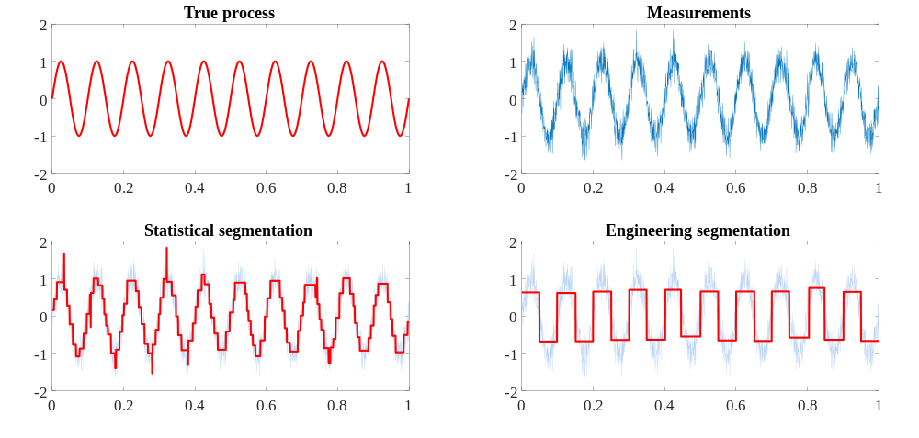

Figure 1. Illustration of AASHTO CDA on a sinusoidal process

Objective
The objective of this paper is to propose a segmentation approach that overcomes the shortcomings of the AASHTO CDA. This approach uses the centered CUMSUM, a feature it shares with the AASHTO CDA. However, the proposed approach (a) uses a different criterion, based on a rigorous statistical test, to define breakpoints, (b) allows the objective implementation of engineering heuristics, and (c) is easily implemented in software. These characteristics are clarified in the description of the proposed approach.
The remainder of the paper is divided as follows. The “Background” section provides a detailed description of the CDA, its limitations, and alternative methods proposed in the literature. The “Proposed Approach” section provides a detailed description of our proposed approach, including the theory, implementation, and required user input parameters. The “Applications” section presents the result of segmentations obtained using the proposed approach on simulated examples and on TSD data. The effect of user input parameters on the resulting segmentation is also investigated and discussed in this section. The paper ends with the “Conclusion” section.

Background
The CDA to segment pavement data was introduced in the AASHTO 1993 design guide (1). It is based on the well-known CUMSUM approach developed by Page (2) used in statistical quality control. The CDA is relatively simple to understand, but many authors have noted its shortcomings (3-9). This background section summarizes the CDA and some well-known alternative methods.

AASHTO CDA Segmentation
The CDA is described in the AASHTO 1993 design guide (1) using an example of three homogeneous sections having different response magnitudes. The guide states that the fundamental concept and ultimate basis to determine section boundaries are the locations where the slope of the cumulative sum of differences changes sign. This is reflected in the following: “the location of unit boundaries always coincides with the locations (along x) where the slope of the Z_{x} function changes algebraic signs (i.e., from negative to positive or vice versa)” (Appendix J). The approach is explained for the case of continuous and discrete data. For the continuous case, the approach consists of calculating $Z_{x}$, as shown in Equations 1 to 4, and determining the locations where the slope of $Z_{x}$ changes sign as illustrated in Figure 2.

$$A_{x}=\int_{0}^{x}{r\left(x\right)dx} (1)$$

$$\overline{r}=\int_{0}^{x_{3}}{\frac{r\left(x\right)}{x_{3}}dx} (2)$$

$${\overline{A}}_{x}=\int_{0}^{x}{\overline{r}dx} (3)$$

$$Z_{x}=A_{x}-{\overline{A}}_{x} (4)$$

In the discrete case with n equally spaced measurements $r_{i}$, i = 1, …, n, the CDA uses $Z_{i}$ instead of $Z_{x}$:
$$Z_{i}=\sum_{j=1}^{i}{r_{j}}-\frac{i}{n}\sum_{j=1}^{n}{r_{j}} (5)$$

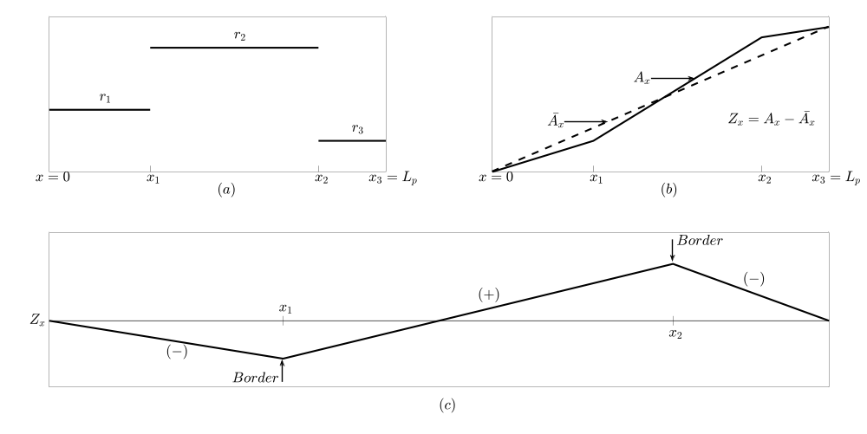

Figure 2 Concepts of CDA to Analysis Unit Delineation (after AASHTO 1993)

The example presented in the AASHTO guide is notably simple. To some extent, it serves as an ideal illustration, though real-world data are seldom that perfect. This leads to significant limitations:

- The location of breakpoints is based on a change in the sign of the slope of Z_{x}. This is not correct, as will be explained later.
- The presence of noise in the data results in spurious changes in the slope of Z_{x}.
- There is a lack of a statistical measure of the significance of a breakpoint.
- There is a lack of a stopping criterion for the segmentation.
- There is no constraint on the minimum segment length.
- There is no constraint on the minimum difference between the average response of adjacent segments.

The first four items on the list are related to mathematical and statistical limitations, while the last two are related to engineering considerations. We will discuss each separately.

Defining Sections Based on Changes in the Sign of the Slope of Z_{x}
The problem with this definition is that the algebraic sign of the slope does not have to change to indicate the presence of two distinct segments. This is easy to illustrate by slightly modifying the example provided in the AASHTO guide. In Figure 3, the third segment from the AASHTO example is split into two, showing the presence of an additional boundary without a change in the slope’s sign (Figure 3(c)). This limitation of the CDA seems to have been first noted by Misra and Das (3) and later reported by others (e.g., 6, 8). This example illustrates that the transition between segments is not marked by a change in the slope’s algebraic sign but rather in the slope’s actual value. While this will work for an ideal case of a piecewise constant profile, it will fail at the slightest deviation caused by data noise, as discussed below.

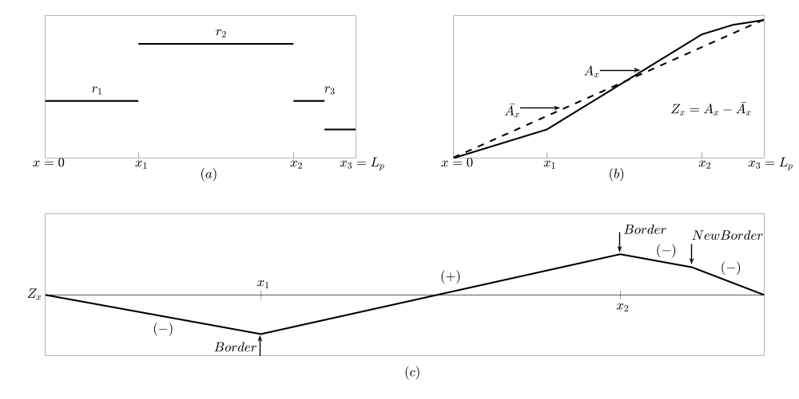

Figure 3 Modifying the AASHTO CDA example to show that the location of unit boundaries does not necessarily always coincide with a change in the algebraic sign of the slope of Z_{x}

Presence of Noise in the Data
In the ideal case, a change in the slope value indicates a boundary between two segments. However, in practical scenarios, slope values change at each point, particularly in the presence of data noise, as depicted in Figure 4. The figure displays 1,000 measurements, all supposedly constant (equal to 1), but small noise causes the slope to vary between the points. One might argue that these minor changes in the slope should be disregarded. However, determining what constitutes a “minor” change and its implementation in software remains ambiguous. While some researchers have suggested employing statistical tests, those tests’ adequacy in the context of the collected data has not been confirmed. Furthermore, most of these statistical tests are applied after the segmentation has been performed, not while identifying the breakpoints.

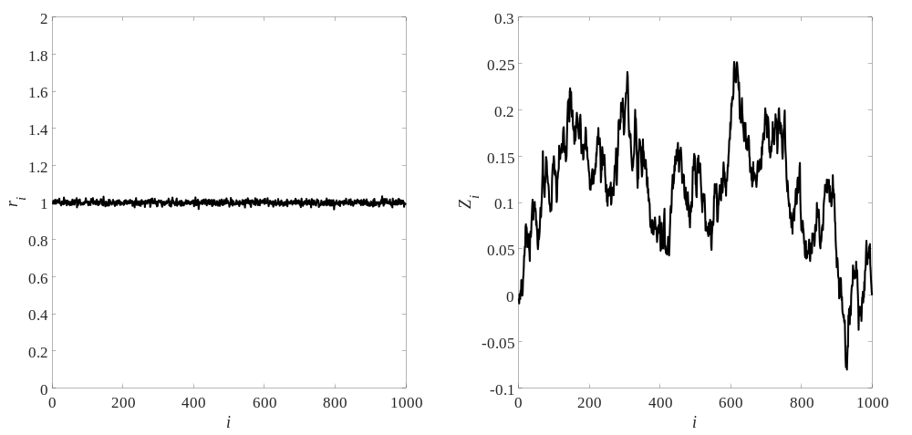

Figure 4 Illustration of the CUMSUM of a constant process showing changes in slope in the presence of noise

Statistical Criteria
The prior section underscored the necessity for a statistical metric to gauge the significance of a breakpoint detected using the CDA. Some researchers have proposed using a t-test to evaluate the significance of the difference in the mean response of two adjacent segments (10-12). This involves performing the statistical test post-segmentation, which falls short of testing the significance of the breakpoint when selected. Furthermore, this approach still defines a breakpoint based on a change of the algebraic sign of the slope, which we have shown is incorrect. A direct approach that works on the mean-centered cumulative sum to test the statistical significance of a breakpoint could be more effective than a post-segmentation approach. There is also the issue—because of the potential presence of multiple breakpoints—of testing multiple hypotheses, which is not addressed by the conventional t-test. Rubensam and Schulze (13) have proposed smoothing the data with a moving average to reduce the noise; however, Thomas (5) argued that smoothing will not address the noise. Another limitation of the CDA, as argued by Thomas (5), is that because the CDA starts and ends at zero, there will be at least one peak in the data and therefore at least one change in the algebraic value of the slope, and hence two sections detected.

Minimum Segment Length
The AASHTO CDA does not incorporate a minimum segment length. However, Ping et al. (11) and Kennedy et al. (14) proposed modifying the CDA to incorporate a minimum segment length constraint. The constraint is applied post-segmentation by merging segments that are smaller than the specified minimum segment length constraint. Similar minimum segment length constraints have been applied post-segmentation by others for segmentation procedures other than the CDA (3, 12, 15).

Minimum Difference between Adjacent Segments
The minimum difference between adjacent segments is another constraint that is important in pavement management. Similar to the minimum segment length constraint, the minimum difference constraint is not implemented in the original AASHTO CDA; however, researchers have also implemented it post-segmentation (3, 11, 12, 14, 15).

Alternative Pavement Segmentation Methods
Many alternatives to the AASHTO CDA have been proposed. Misra and Das (3) proposed a method based on the classification and regression trees (CART) algorithm of Breiman et al. (16). After obtaining the CART segmentation tree, Misra and Das (3) modified the tree based on minimum section length and total number of sections. Cuhadar et al. (17) and Boroujerdian et al. (18) proposed using the wavelet transform. However, that approach seems to only be able to identify sudden changes. Cafiso and Di Graziano (12) proposed an iterative approach based on minimizing the sum of squared error (MINSSE). El Gendy and Shalaby (19) proposed using the absolute difference approach, and later El Gendy and Shalaby (6) proposed using control charts, which are similar to the absolute difference approach. Some problems with these methods are that they are very sensitive to heavy-tailed distributions and outliers in the data, and they require defining a threshold to identify breakpoints. How this threshold is selected can be problematic. For example, in the control charts approach, El Gendy and Shalaby (6) suggested a threshold of 3 times the standard deviation. This choice depends on the assumption that data are normally distributed, and it is inadequate for other distributions. Even if the error is normally distributed, 3 times the standard deviation is not adequate when there are multiple measurements. This is because given n independent identically distributed normal observations, the probability that at least one of those observations deviates from the mean by more than t times the standard deviation is given by Equation 6:

$$P\left(\left|y-μ\right|≥tσ\right)=1-{\left(1-2Φ\left(\frac{\left|tσ-μ\right|}{σ}\right)\right)}^{n} (6)$$

While for t = 3 and n = 1, this probability is 0.0027, for n = 100 this probability is 0.24, and for n = 1,000 it is 0.93. Clearly, 3 times the standard deviation is not an appropriate threshold to use with large values of n.
Thomas (4, 5) developed a Bayesian approach based on an autoregressive model. Although the approach was initially developed with no assumptions of a statistical distribution, it was later modified with the Box-Cox transformation for normality considerations. The approach is very computationally intensive and not easily modified to include common engineering constraints such as minimum segment length and minimum difference between adjacent segments. Kim and Prozzi (8) proposed a segmentation based on hidden Markov models (HMM). One of the main attractive features of the approach is that it can consider multiple measures of pavement condition at the same time. However, the approach is computationally intensive and requires the selection of the number of states of the hidden variables.

Proposed Approach
The primary limitations of the CDA include its reliance on changes in the algebraic sign of the slope to identify breakpoints and its lack of a statistical metric to validate the detected breakpoints. Although some authors have proposed the use of a t-test to validate that the difference between two identified segments is statistically significant, they still rely on the change in slope sign to identify breakpoints. In our proposed approach, the location of the maximum deviation in the CDA profile (maximum or minimum of the CDA profile) is identified as a potential breakpoint. This identified breakpoint is then rigorously tested at a chosen significance level to determine if it represents a genuine change in the mean response or merely reflects variations due to noise. Compared to the AASHTO change of algebraic slope sign approach to identify breakpoints, this approach is very robust to the noise. The segmentation process is iteratively applied to each identified segment until no further significant breakpoints are found. The proposed approach provides asymptotic theoretical performance guarantees for any noise distribution having finite variance. That is, given exactly m segments, each having a different but constant mean response (i.e., there are no additional breakpoints in any of the m segments), then the proposed approach used on these m segments to identify potential breakpoints with a significance level α will correctly not identify any breakpoint in (1-α)% of the cases. More details on this performance guarantee are provided in the subsection below, and numerical examples are provided to show practical performance in the case of a finite number of observations.

Identification of a Breakpoint
Suppose we are given n observations r_{i}, i = 1, …, n. We calculate the mean-shifted cumulative sum Z_{i} as follows:

$$Z_{i}=\sum_{j=1}^{i}{\left(r_{j}-\overline{r}×i\right)} (7)$$

$$\overline{r}=\sum_{j=1}^{n}{r_{j}} (8)$$

Under the null hypothesis of independent (white) noise having finite variance $σ^{2}$ (note that no distribution is specified for what follows to be true; just that the distribution has a finite variance), the statistic ${Z_{i}}/{\left(σ\sqrt{n}\right)}$ behaves asymptotically like a standard Brownian bridge on the interval [0, 1] (20, 21). Let

$$λ=\max_{1≤i≤n}\left|{Z_{i}}/{\left(σ\sqrt{n}\right)}\right| (9)$$

Then, the cumulative distribution of $λ$ converges to the distribution of the supremum of the absolute value of the Brownian bridge $M\left(τ\right)$, $0≤τ≤1$ given in Equation 10 (see 20):

$$F\left(sup\left|M\left(τ\right)\right|≤t\right)=1+2\sum_{j=1}^{∞}{{\left(-1\right)}^{j}exp\left(-2j^{2}t^{2}\right)} (10)$$

In Equation 10, t is the threshold value that $λ$ exceeds in $α=F\left(sup\left|M\left(τ\right)\right|≤t\right)$ fraction of the cases when the n observations come from a uniform segment with no breakpoints. The infinite sum in the equation converges quickly because as j increases, the exponential term rapidly converges to zero. Furthermore, the terms in the sum alternate sign, which allows us to evaluate the error of approximating the infinite sum with a finite sum. Therefore, if we define the finite sum given in Equation 11:

$$F_{q}\left(t\right)=1+2\sum_{j=1}^{q}{{\left(-1\right)}^{j}exp\left(-2j^{2}t^{2}\right)} (11)$$

then the error of approximating F with F_{q} is found in Equation 12:

$$\left|F-F_{q}\right|≤\left|{\left(-1\right)}^{q+1}exp\left(-2{\left(q+1\right)}^{2}t^{2}\right)\right|=exp\left(-2{\left(q+1\right)}^{2}t^{2}\right) (12)$$

If we use the finite sum to determine the threshold t that corresponds to the significance level α, then the error in the true significance level will be small. For example, using F₁ to determine the threshold t for a significance level α = 0.05 (F₁ = 1 – α = 0.95) results in Equation 13:

$$t=\sqrt{-\frac{1}{2}log\left(\frac{1-0.95}{2}\right)}=1.3581 (13)$$

Because we have used the finite sum instead of the infinite sum to determine t, t will not be the exact threshold for α = 0.05 but for a significance level $\tilde{α}$ that is slightly different from α. An upper bound for the difference between α and $\tilde{α}$ is given by Equation 14, which is obtained by substituting a value of q = 1 in Equation 12.

$$\left|\tilde{α}-α\right|=\left|\tilde{α}-0.05\right|=\left|F_{1}-F\right|≤exp\left(-2{\left(1+1\right)}^{2}t^{2}\right)=exp\left(-8{\left(1.3581\right)}^{2}\right)<exp\left(-14.755\right)≈0.00000039 (14)$$

The value obtained in Equation 14 is very small and for all practical purposes can be neglected. Figure 5 shows the values of t, calculated using F₁, for F between 0.95 and 0.99999 (α between 0.00001 and 0.05).

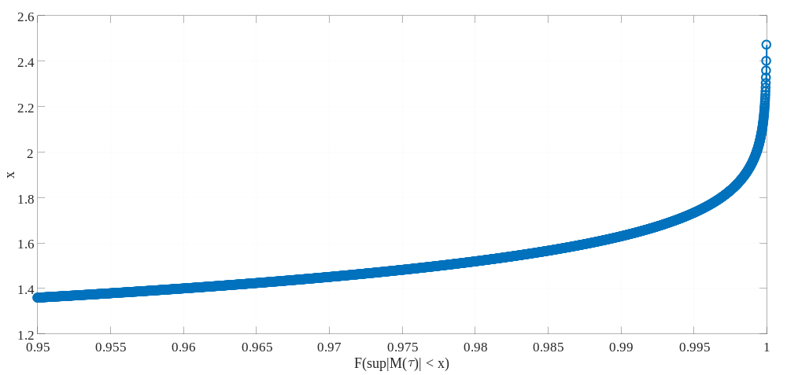

Figure 5 t as a function of F₁

Iterative Segmentation
The procedure presented in the previous subsection can be used to determine the presence of a breakpoint in a given data segment. To perform the segmentation, we propose an iterative segmentation procedure that tests for the presence of a breakpoint in any of the already identified segments. For this purpose, we select a significance level α, typically α = 0.05, start with one segment (the whole data), and iteratively test for the presence of a breakpoint as follows:

- Let ℓ = 1, be the number of identified segments. Obtain
$$λ=\max_{1≤i≤n}{{Z_{i}}/{σ\sqrt{n}}}$$
  - If $λ≥t_{α}$, where $t_{α}$ is the asymptotic critical value for a given significance level $1-α$, define $m_{1}$ as the point where $Z_{i}$ achieves its maximum value. Then go to step 2.
  - If $λ<t_{α}$, the mean response is constant and the procedure ends.
- Let ℓ = ℓ + 1. Repeat step 1 by calculating $λ^{k}$, $k=1,…,l+1$, for every section in the segmentation with $α_{l}=α/l$ (Bonferroni correction) and select the maximum $λ^{k}$. That is, calculate
$$λ=max\left\{λ^{k},k=1,…,l\right\}$$
where,
$$λ^{k}=\max_{m_{k-1}≤i≤m_{k}}{{Z_{i}}/{σ\sqrt{n_{k}}}}$$
If $λ≥t_{α_{l}}$, define $m_{l}$ as the point where $λ$ is achieved. Otherwise, end the procedure.

At the end of the procedure, we have the set $S$ of detected breakpoints given by $S=\left\{m_{0},m_{1},…,m_{l+1}\right\}$, where $m_{0}=1$ and $m_{l+1}=n$. The use of $α_{l}=α/l$ is a Bonferroni-type correction for testing ℓ hypotheses. The use of $n_{k}$ in the equation $λ^{k}=\max_{m_{k-1}≤i≤m_{k}}{{Z_{i}}/{σ\sqrt{n_{k}}}}$ adjusts for the length of the different segments that have been determined at each step ℓ.
To determine the standard deviation $σ$, we can assume that under the null hypothesis (i.e., the whole data consists of one segment), $\hat{σ}$ as given by Equation 15

$$\hat{σ}=\sqrt{\sum_{i=1}^{n}{\frac{{\left(r_{i}-\overline{r}\right)}^{2}}{n-1}}} (15)$$

is an unbiased estimate of $σ$. This estimate will be overly conservative if the null hypothesis is not correct (i.e., there is at least one breakpoint). A better estimate can be obtained by taking the difference between consecutive measurements and estimating the standard deviation based on that difference, as in Equation 16. This approach is one example of the “difference sequence methods” used in statistics to estimate noise standard deviations (22-27).

$$\hat{σ}=\sqrt{\sum_{i=1}^{n-1}{\frac{{\left(x_{i+1}-x_{i}\right)}^{2}}{2\left(n-1\right)}}} (16)$$

This is also a conservative estimate, but it is better than the estimate obtained using Equation 15. Equations 15 and 16 are not specific to any error distribution and therefore can always be applied. If the noise distribution is known to be normal, then a more robust and accurate estimate of the standard deviation can be obtained as follows. Let

$$x_{\text{med}}=\text{median}\left(r_{1}, r_{2},r_{3},…,r_{n-1},r_{n}\right) (17)$$

$$d_{i}=\left|r_{i+1}-r_{i}\right|-x_{\text{med}} (18)$$

then
$$\hat{σ}=\frac{1.4826}{\sqrt{2}}×\text{median}\left(d_{1},d_{2},…,d_{n-1}\right) (19)$$

We recommend that, unless it is known with confidence that the data noise is normally distributed, Equation 16 be used. In case the noise standard deviation is not the same in every segment, we can separately estimate it for every identified segment using any of the above methods.

Implementation of a Minimum Segment Size
The minimum segment size constraint, denoted by L, is applied during the segmentation. The constraint ensures that only segments that are larger than 2L can be segmented without violating the constraint. If a segment size exceeds 2L, then potential breakpoints must be located at least a distance L away from either end of the segment. Applying the constraint during segmentation rather than merging segments smaller than the minimum segment size after segmentation is, in our opinion, a better approach. The reason can be illustrated in a simple example: Consider a 1,000-m segment that is composed of two uniform segments—one 190 m in length and another 810 m in length—subject to a 200-m minimum segment length constraint. If the constraint is applied after segmentation, the initial division results in one 190-m and another 810-m segment (refer to Figure 6). However, because of the 200-m constraint, the two segments are merged back into a single 1,000-m segment. In contrast, applying the constraint during segmentation leads to only the potential breakpoints located between 200 m and 800 m being considered. Consequently, this will result in a segment measuring 200 m in length and another measuring 800 m in length, which is closer to the ground truth than a single 1,000-m segment.

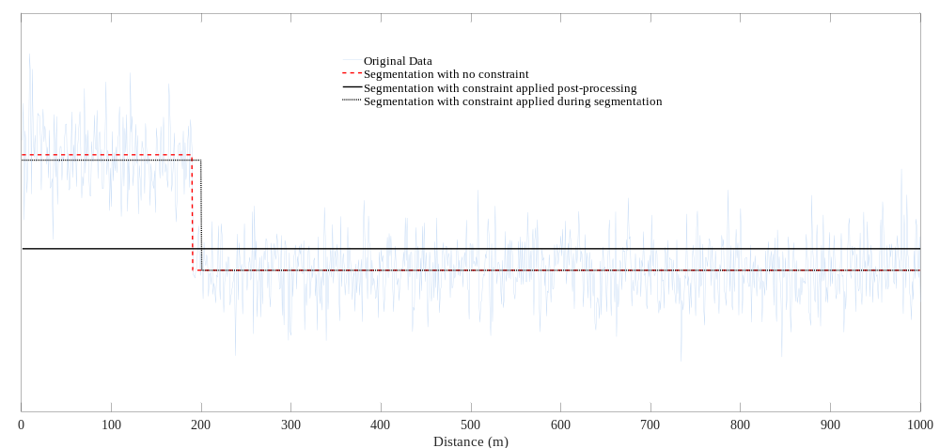

Figure 6 Illustration applying minimum segment size constraint during segmentation and post-segmentation

Minimum Difference between Adjacent Sections
The minimum difference between adjacent segments constraint is applied post-segmentation. The reason for this choice—rather than applying the constraint during segmentation—is because the difference between adjacent segments changes during the segmentation; it can increase or decrease. Therefore, even if the difference between the two adjacent segments created by adding a new breakpoint is initially smaller than the minimum difference constraint, it might become larger as the segmentation algorithm adds more segments. Figure 7(a) shows an example of 1,000 measurements consisting of 12 segments (this is the “Blocks” function, which is introduced later in the paper). Figure 7(b) shows the difference between the first two segments obtained during the segmentation—the first iteration of the algorithm—as a function the breakpoint location. The maximum difference is less than 1. Figure 7(c) shows the difference between the adjacent segments of Figure 7(a). If a minimum difference constraint of 1 between the adjacent segments is applied post-segmentation, all the differences between adjacent sections will satisfy this constraint and no segments will be merged. However, if the constraint is applied during the segmentation, then all possible splits during the first iteration of the segmentation algorithm do not satisfy this constraint. Therefore, no split will occur, and the segmentation will stop with only one segment consisting of the average of the collected measurements. Clearly, the approach of applying the constraint post-segmentation is better. Applying the constraint post-segmentation works because the difference can increase. In contrast, for the case of minimum segment size constraint, the segment size decreases or stays the same at each subsequent iteration of the segmentation algorithm. Therefore, if at iteration i a newly created segment does not satisfy the minimum segment size constraint, then it will not satisfy it at all subsequent iterations. Therefore, in the case of minimum segment size constraint, there is no need to wait for the segmentation algorithm to stop before applying the constraint.

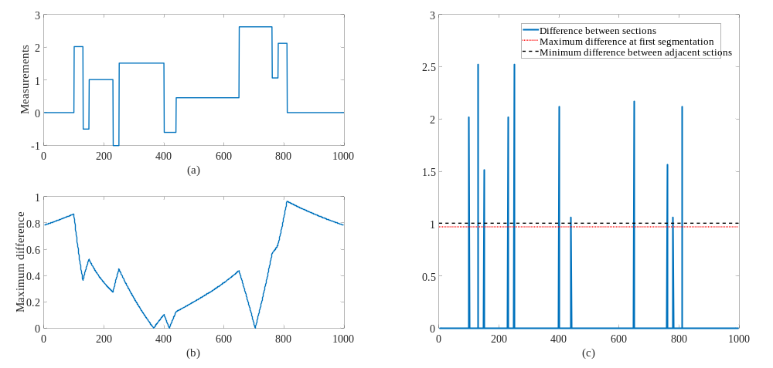

Figure 7. Segmentation of Blocks with minimum difference constraint

Applications
In this section, we evaluate the performance of the proposed segmentation approach on simulated data and on pavement deflection data collected by the traffic speed deflectometer (TSD).

Simulated Data
We use three examples to evaluate the performance of the proposed approach to delineate changes in the mean response, with simulated data. The first example consists of a single uniform segment and is used to demonstrate the proposed approach’s performance when no breakpoints exist in the data. The second example uses the “Blocks” function of Donoho and Johnstone (28), which comprises 12 uniform segments. Both the single segment and the “Blocks” function examples are evaluated using 2,000, 20,000, and 200,000 data points at significance levels of α = 0.05 and α = 0.20, to determine if the approach can control, at the specified level α, the Type I error rate of falsely identifying breakpoints. This is done for various noise distributions derived from the generalized Gaussian distribution family, which includes the normal distribution as a special case but can model distributions with heavier and lighter tails. The third example uses the “Bumps” function of Donoho and Johnstone (28), tested with 2,000 sampled data points and added normally distributed noise. The “Bumps” function is used as an example of a function that deviates from the ideal piecewise constant function. Because the “Bumps” function is not piecewise constant, the Type I error rate of identifying breakpoints is not defined. Therefore, we evaluate the MSE and mean absolute error (MAE) performance of the segmentation procedure for significance levels of α = 0.05 and α = 0.50. We also evaluate how the segmentation changes for different specified minimum segment size constraints for the case α = 0.05. The “Blocks” and “Bumps” functions are defined by Equation 24 and Equation 25 based on the terms presented in Equations 20 to 23, and Figure 8 shows the two functions sampled with 2,000 points and scaled to have a standard deviation of 7.

$$0≤t≤1 (20)$$

$$\left(t_{j}\right)=\left(0.1, 0.13, 0.15, 0.25, 0.40, 0.44, 0.65, 0.76, 0.78, 0.81\right) (21)$$

$$\left(h_{j}\right)=\left(4, -5, 3, -4, 5, -4.2, 2.1, 4.3, -3.1, 2.1, -4.2\right) (22)$$

$$\left(w_{j}\right)=\left(0.005, 0.005, 0.006, 0.01, 0.01, 0.03, 0.01, 0.01, 0.005, 0.008, 0.005\right) (23)$$

$$Blocks: f\left(t\right)=\sum_{j}{h_{j}K\left(t-t_{j}\right)}, K\left(t\right)={\left\{1+\text{sgn}\left(t\right)\right\}}/2 (24)$$

$$Bumps: f\left(t\right)=\sum_{j}{h_{j}K\left({\left(t-t_{j}\right)}/{w_{j}}\right)}, K\left(t\right)={\left(1+\left|t\right|\right)}^{-4} (25)$$

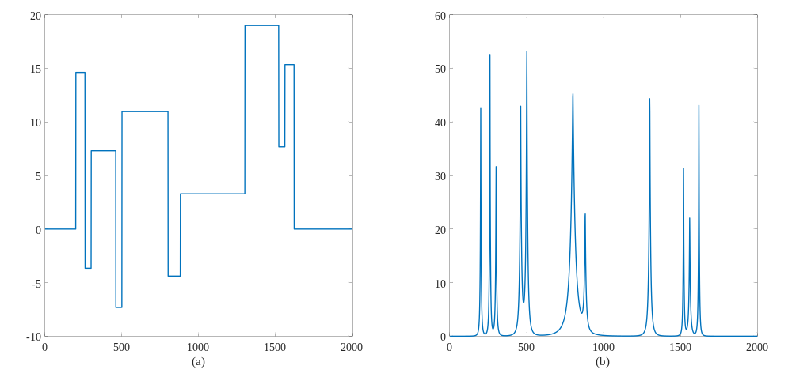

Figure 8 2,000 point samples of (a) “Blocks” and (b) “Bumps” functions scaled to have a standard deviation of 7

The generalized Gaussian distribution that is used to generate the simulated error in the examples is given by Equation 26:

$$f\left(x | a,β\right)=\frac{β}{2aΓ\left(1/β\right)}e^{-{\left({\left|x-μ\right|}/a\right)}^{β}} (26)$$

Where $Γ$ denotes the gamma function

$$Γ\left(x\right)=\int_{0}^{∞}{t^{x-1}e^{-t}dt} (27)$$

The mean and variance of the distribution are given by

$$E\left[x\right]=μ (28)$$

$$Var\left[x\right]=E\left[x^{2}\right]-E\left[x\right]=\frac{a^{2}Γ\left(3/β\right)}{Γ\left(1/β\right)} (29)$$

The normal distribution is obtained by setting $β=2,$ and the Laplace distribution is obtained by setting $β=1$. Figure 9 shows 2,000 random samples drawn from the distribution for different values of $β$. We can observe that random samples generated with $β=0.5$ and $β=0.25$ would be challenging for most segmentation procedures because of the large deviations of the random samples from the mean.

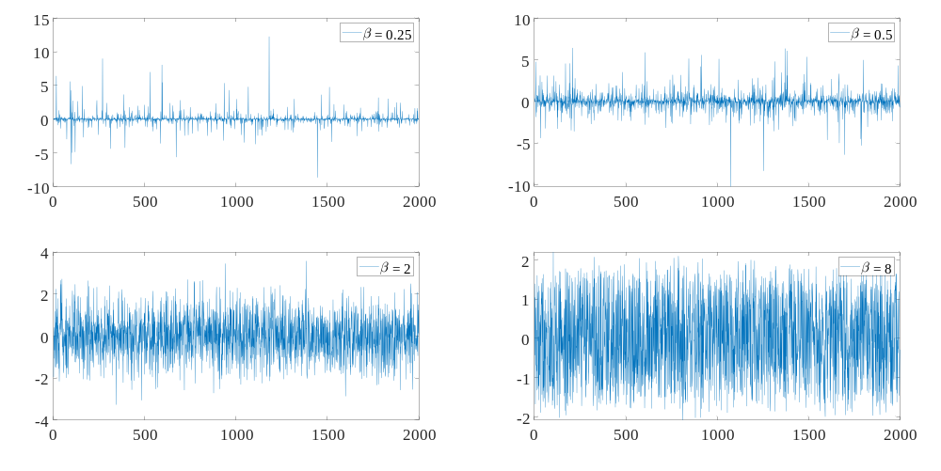

Figure 9 Random samples generated from the generalized Gaussian distribution with different values of β. The value of a was set so that the resulting variance is equal to 1.

Single Uniform Segment and “Blocks” Function
In this section, we evaluate the performance of the proposed approach in the “ideal” cases of uniform segments. The first case consists of a single uniform segment, and the second of a case of 12 uniform segments (“Blocks” function). We evaluate the performance with different noise distributions by letting $β=0.25, 0.5, 2, and 8$. An example of generated data with $β=0.25$ is shown in Figure 10. We evaluate the experimental probability of wrongly identifying breakpoints for α = 0.05 and α = 0.20 for the cases of 2,000, 20,000, and 200,000 measurements with the results presented in TABLE 1. For a single uniform segment, the experimental probability is in all cases less than the selected level α, showing that the proposed approach controls the Type I error at the specified level. For 12 uniform segments, the experimental probability is within the selected level α for all cases except for the case of $β=0.25$ and sample sizes of 2,000 and 20,000 and the case of $β=0.5$, $α=0.05$, and sample size of 2,000. These cases represent extreme tails of error distribution, which seldom occur in data collected on pavement sections. The main reason that the approach fails to control the Type I error rate is that the theoretical results presented in the “Proposed Segmentation Approach” section are asymptotic results, meaning they apply in the limit as the number of observations increases to infinity. Therefore, the results can fail in the finite sample case, especially as the tails of the error distribution become more extreme. The “Blocks” function example consists of 12 segments and, in the case of 2,000 observations, three of those segments consist of 40 observations, which is a very small sample size (note that this is not an issue for normally distributed error).

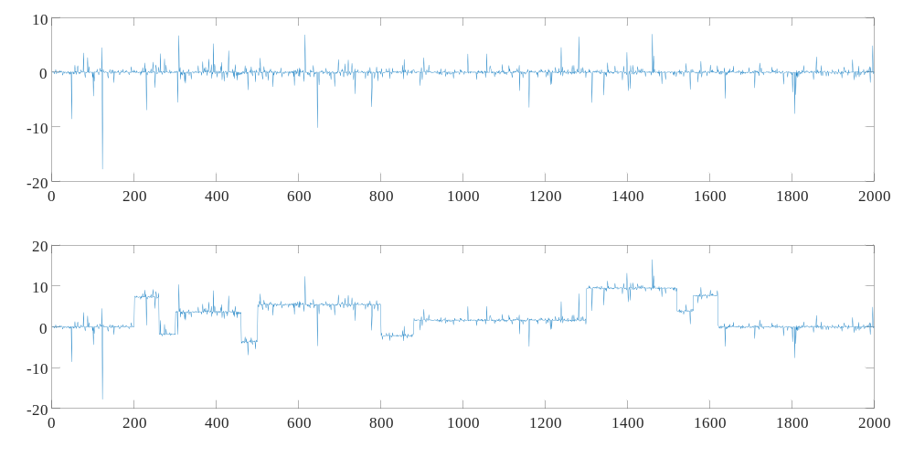

Figure 10. Example of simulated data for the uniform segment (top) and “Blocks” function (bottom) with $β=0.25$

TABLE 1 Type I Error Rate of the Simulation Study. Each Error Rate is Calculated Using 10,000 Simulated Examples
Simulated Case | Significance Level, α | β | Empirical Error Rate for Different Number of Observations
Simulated Case | Significance Level, α | β | 2,000 | 20,000 | 200,000
Uniform Segment | 0.05 | 0.25 | 0.036 | 0.043 | 0.044
Uniform Segment | 0.05 | 0.5 | 0.042 | 0.047 | 0.046
Uniform Segment | 0.05 | 2 | 0.047 | 0.049 | 0.048
Uniform Segment | 0.05 | 8 | 0.046 | 0.051 | 0.049
Uniform Segment | 0.2 | 0.25 | 0.165 | 0.189 | 0.199
Uniform Segment | 0.2 | 0.5 | 0.183 | 0.199 | 0.198
Uniform Segment | 0.2 | 2 | 0.184 | 0.197 | 0.199
Uniform Segment | 0.2 | 8 | 0.186 | 0.197 | 0.193
Blocks function | 0.05 | 0.25 | 0.237 | 0.110 | 0.042
Blocks function | 0.05 | 0.5 | 0.082 | 0.045 | 0.049
Blocks function | 0.05 | 2 | 0.025 | 0.046 | 0.049
Blocks function | 0.05 | 8 | 0.028 | 0.042 | 0.048
Blocks function | 0.2 | 0.25 | 0.325 | 0.244 | 0.175
Blocks function | 0.2 | 0.5 | 0.197 | 0.182 | 0.177
Blocks function | 0.2 | 2 | 0.137 | 0.177 | 0.171
Blocks function | 0.2 | 8 | 0.119 | 0.191 | 0.179

“Bumps” Function
The one-segment and “Blocks” function examples are ideal cases of mathematically uniform segments (piecewise constant). In this section, we evaluate the performance of the proposed approach on the “Bumps” function, which does not consist of piecewise constant segments. The segmentation can still be applied in this case except that, because the underlying process does not consist of piecewise constant segments, the Type I error of identifying breakpoints is not defined. Therefore, we evaluate the segmentation performance in terms of MSE and MAE. The “Bumps” function along with simulated noisy observations from the function are shown in Figure 11. The MSE and MAE as a function of the number of segments are shown in Figure 12. The segmentations obtained with $α=0.05$ and $α=0.5$ result in MSE and MAE values that are very close to the optimal MSE and MAE segmentations. This shows that when the data do not come from a piecewise constant process, the proposed segmentation provides a good piecewise constant fit to the process that generated the data.

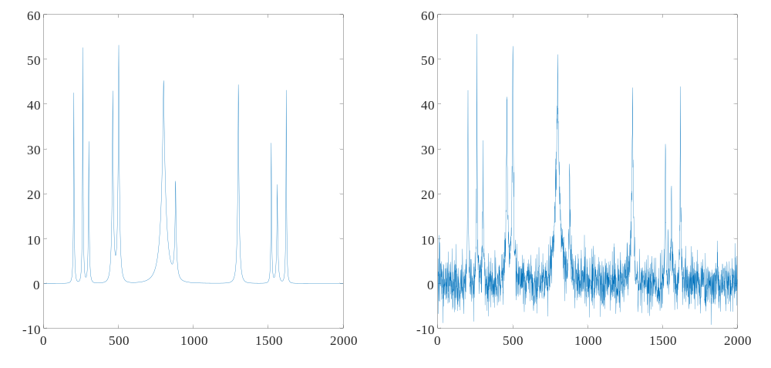

Figure 11. Bumps function and noisy Bumps function with added Gaussian noise with a standard deviation of 3

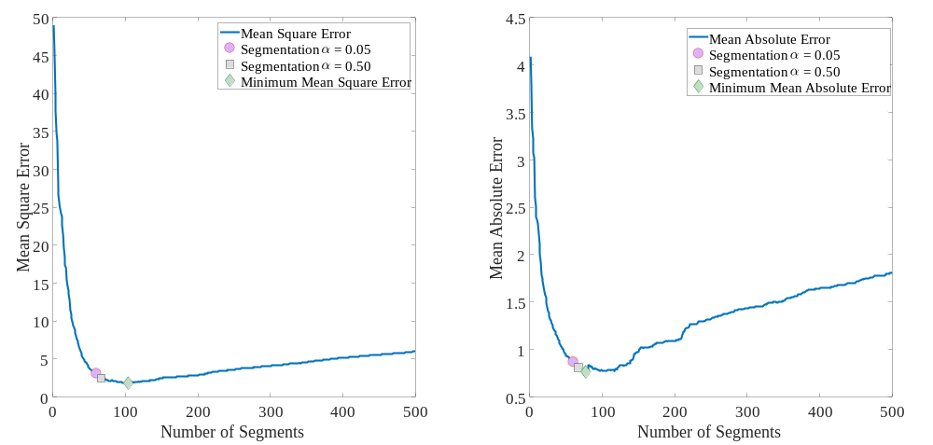

Figure 12. MSE and MAE as a function of the number of segments for the “Bumps” function shown in Figure 11. The solution for α = 0.05 (60 segments), α = 0.5 (67 segments), and optimal solution (104 segments for MSE and 77 segments for MAE) are indicated in the figure.

We next evaluate the performance of the proposed approach with α = 0.05 in terms of specifying a minimum segment size constraint of 1 observation (Case 1; equivalent to no constraint), 20 observations (Case 2), 50 observations (Case 3), and 75 observations (Case 4). The results are presented in Figure 13. Case 1 resulted in 60 segments, Case 2 in 25 segments, Case 3 in 14 segments, and Case 4 in 11 segments. As expected, specifying a minimum segment length lowers the number of segments. Which segmentation is the best depends on the specific data and the context in which it is being used. For example, the minimum segment size constraint can be different whether we are performing a project-level or a network-level analysis.

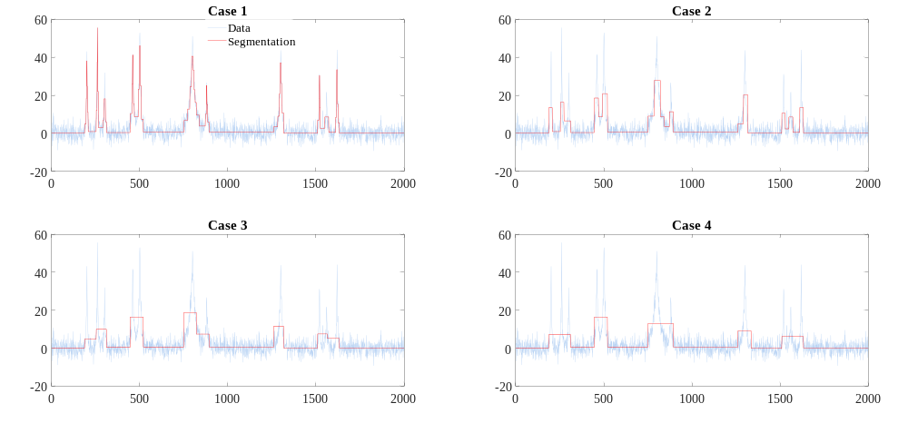

Figure 13 Segmentations with different minimum segment size constraints

TSD Data
We evaluated the proposed segmentation procedure on TSD D₀ deflection data collected on I-90 (about 70 miles) in Idaho. The segmentation is fully automated, and the user needs only to specify the statistical significance level α, the minimum segment size, and the minimum difference between adjacent sections. Note that to run the procedure, it is sufficient to only specify one of the three parameters, any combination of two parameters, or all three parameters. A value of α = 0.05 is used for all the results presented in this section. Figure 14 shows the results of the segmentation for different specified minimum segment size constraints. The data are collected at 0.01 miles; therefore, the case of 0.01 minimum segment size is equivalent to not specifying a minimum segment size. The number of identified breakpoints for each specified minimum segment size constraint is reported in TABLE 2. Figure 15 shows the results of the segmentation with a 1-mile minimum segment size constraint and different constraints on the minimum difference between adjacent segments (the 0 minimum difference constraint is equivalent to no constraint). In the case of the minimum difference constraint, a segmentation obtained at a specific constraint threshold is necessarily a subset of all segmentations obtained at a lower threshold of that constraint. This is because the minimum difference constraint is imposed after the initial segmentation with no constraint is applied, and it consists of iteratively removing breakpoints from the set of obtained breakpoints with no constraint. The number of segments obtained in the segmentation is also presented in TABLE 2.

TABLE 2 Number of Identified Breakpoints for Different Constraints
Segment Size Constraint | Minimum Difference Constraint | Number of Breakpoints | Common Breakpoints with Previous
0.01 miles | 0 | 140 | Not Applicable
0.1 miles | 0 | 123 | 119
0.2 miles | 0 | 100 | 92
0.5 miles | 0 | 71 | 57
1 mile | 0 | 44 | 35
2 miles | 0 | 22 | 15
5 miles | 0 | 9 | 5
10 miles | 0 | 3 | 3
1 mile | 0 mils | 44 | Not Applicable
1 mile | 1 mil | 37 | 37
1 mile | 2 mils | 16 | 16
1 mile | 5 mils | 6 | 6

It might be tempting, when performing the segmentation, to try different constraint combinations, plot the results (as we have done in this paper), and decide based on visual inspection of the plots which segmentation is the “best.” However, we do not recommend following this approach. Visual inspection of plots is very subjective, and decisions based on it can vary depending on the length of road that is included in the plot. For example, if we look at the segmentations in Figure 15, we might select the one with the 2 mils minimum difference constraint based on visual inspection. However, if we zoom to the road section between 50 and 60 miles, we might prefer the segmentation with the 1 mil minimum difference constraint. This shows that visual inspection can be misleading. Although we do not advocate using visual inspection, the choice of constraints can vary depending on the applications. For example, the 2 mils constraint might be a good constraint for network-level analysis, while the 1 mil constraint might be appropriate for project-level analysis. This will result in different segmentations, but this difference is based on the specific analysis being carried out, not on a subjective visual inspection.

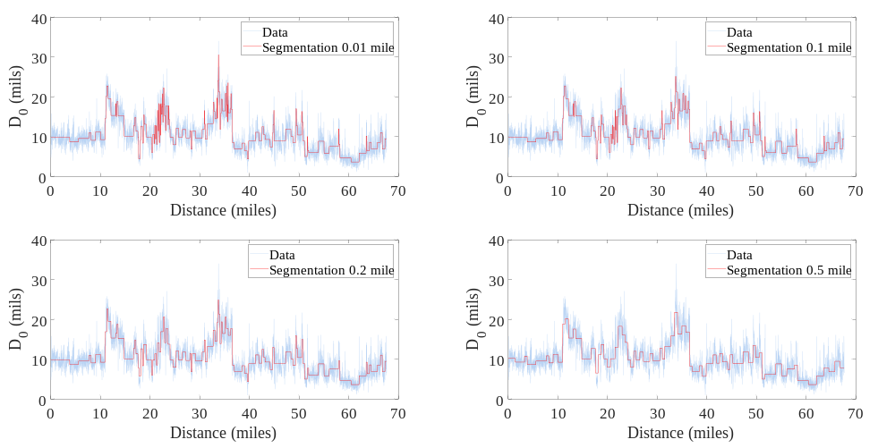
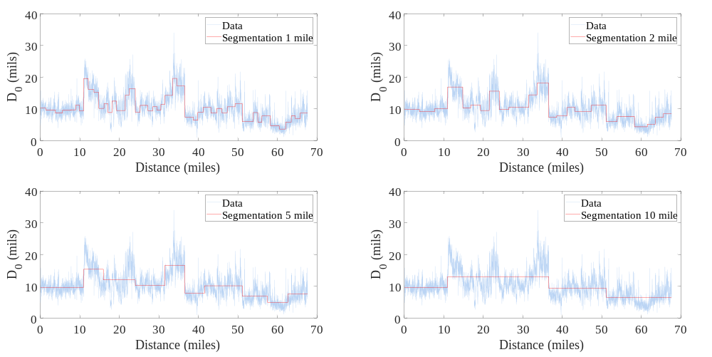

Figure 14 Segmentation on I-90 with α = 0.05 and different minimum segment size constraints

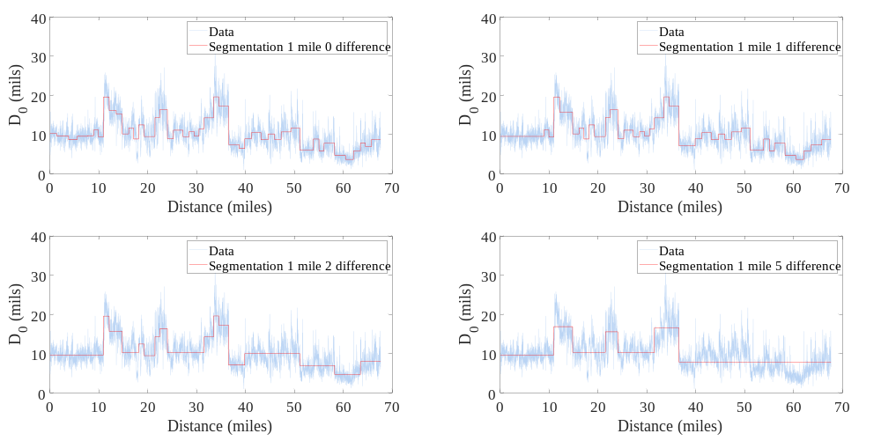

Figure 15 Segmentation on I-90 with α = 0.05, 1-mile minimum segment size constraint, and different minimum difference between adjacent sections constraints

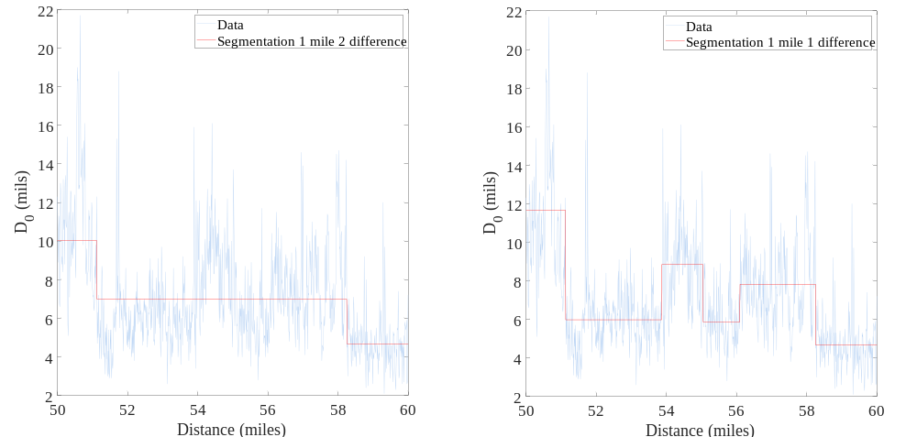

Figure 16 Details from Figure 15

Conclusion and Future Work
We have proposed a segmentation procedure that modifies the AASHTO CDA to address its limitations. The fundamental deficiency of the AASHTO CDA is that breakpoints are identified based on the change in the algebraic sign of the zero-centered CUMSUM. This is a major limitation of the AASHTO CDA, and in the proposed approach, the breakpoints are identified based on the maximum value of the zero-centered CUMSUM, which has a rigorous statistical justification. Simulation studies confirm that when the data consist of piecewise constant segments with added random error, the Type I error rate is controlled at the chosen significance level α. When the data do not consist of piecewise constant segments, the proposed approach results in a segmentation with low MSE or MAE that is close to the optimal MSE and MAE segmentations. Furthermore, the proposed approach implements a minimum segment size constraint and a minimum difference between adjacent sections constraint. Unlike many authors who have implemented a minimum segment size constraint post-segmentation, in our approach the minimum segment size constraint is implemented during the segmentation, which results in a better segmentation.
The proposed approach was then used at a significance level α = 0.05 on TSD data collected at 0.01-mile intervals on I-90 in Idaho. Different constraint combinations were used to illustrate the resulting segmentation. We argued that visual inspection of the resulting segmentations at the different constraint scenarios is not recommended to select the “best” segmentation. Rather, the segmentation should be obtained with constraints that should be selected based on the context under which the data are being used. An example of context is project-level or network-level analysis.
Finally, we have focused on the change in the mean response of the collected data. However, the proposed approach can also, with small modifications, be used to determine a change in the variance (or standard deviation) of the error in the data. There is also the possibility of having a segmentation procedure that considers both a change in the mean response and a change in the variance. This is an avenue that should be explored.

Acknowledgments
Funding for this paper was provided by the Transportation Pooled Fund Study TPF-5(385) Pavement Structural Evaluation with Traffic Speed Deflection Devices (TSDDs) managed by the Virginia Department of Transportation.

Author Contributions
The authors confirm contribution to the paper as follows: study conception and design: S. Katicha, G. Flintsch; data analysis; S. Katicha; interpretation of results: S. Katicha; draft manuscript preparation: S. Katicha. All authors reviewed the results and approved the final version of the manuscript.

Declaration of Conflict of Interest
The authors have no conflict of interest to declare.

References
1. AASHTO. Guide for Design of Pavement Structures. American Association of State Highways and Transportation Officials, Washington, D.C., United States, 1993.

2. Page, E. S. Continuous inspection schemes. Biometrika, Vol. 41, No. 1/2, 1954, pp. 100-115.

3. Misra, R., and Das, A. Identification of homogeneous sections from road data. International Journal of Pavement Engineering, Vol. 4, No. 4, 2003, pp. 229-233.

4. Thomas, F. Statistical approach to road segmentation. Journal of transportation engineering, Vol. 129, No. 3, 2003, pp. 300-308.

5. Thomas, F. Generating homogeneous road sections based on surface measurements: Available methods. Reprint from 2nd European Pavement and Asset Management Conference, 21-23 March 2004, Berlin Germany.(Paper no. 48). Statens väg-och transportforskningsinstitut., VTI särtryck 360A, 2004.

6. El Gendy, A., and Shalaby, A. Using quality control charts to segment road surface condition data. In Proceedings of the Seventh International Conference on Managing Pavement Assets, Calgary, Alta, 2008.

7. Haider, S. W., and Varma, S. Another look at delineation of uniform pavement sections based on falling weight deflectometer deflections data. Canadian Journal of Civil Engineering, Vol. 43, No. 1, 2016, pp. 40-50.

8. Kim, M.Y., and Prozzi, J. Segmentation of Highway Networks for Maintenance Operations. CHPP Report-UTA#8-2021. Center for Highway Pavement Preservation, 2021.

9. Biswas, S., and Kuna, K. K. Optimal Change-Point Analysis of Pavement Condition Data for Identification of Homogeneous Sections. Journal of Transportation Engineering, Part B: Pavements, Vol. 149, No. 1, 2003, 04022078.

10. Divinsky, M., Nesichi, S., and Livneh, M. Development of a road roughness profile delineation procedure. Journal of testing and evaluation, Vol. 25, No. 4, 1997, pp. 445-450.

11. Ping, W. V., Yang, Z., Gan, L., and Dietrich, B. Development of procedure for automated segmentation of pavement rut data. Transportation Research Record, Vol. 1655, No. 1, 1999, pp. 65-73.

12. Cafiso, S., and Di Graziano, A. Definition of homogenous sections in road pavement measurements. Procedia-Social and Behavioral Sciences, Vol. 53, 2012, pp. 1069-1079.

13. Rubensam, J., and Schulze, F. Entwicklung einer Methodik zur zweckmäßigen Zusammenfassung maßnahmebedürftiger Abschnitte der BAB-Betriebsstrecken auf der Grundlage von Zustands- und Bestandsdaten. Forschung Straßenbau und Straßenverkehrstechnik, Heft 736, Bundesministerium für Verkehr, Abteilung Straßenbau, Bonn-Bad Godesberg, Germany, 1996. In German.

14. Kennedy, J., Shalaby, A., and Cauwenberghe, R. V. Dynamic segmentation of pavement surface condition data. In 3rd Transportation Specialty Conference of the Canadian Society for Civil Engineering, London, Ontario (pp. 7-10), 2000.

15. Yang, C., Tsai, Y., and Wang, Z. Algorithm for spatial clustering of pavement segments. Computer‐Aided Civil and Infrastructure Engineering, Vol. 24, No. 2, 2009, pp. 93-108.

16. Breiman, L., Friedman, J., Olshen, R.A., and Stone, C.J. Classification and regression trees. Chapman and Hall/CRC, 2017.

17. Cuhadar, A., Shalaby, K., and Tasdoken, S. Automatic segmentation of pavement condition data using wavelet transform. In IEEE CCECE2002. Canadian Conference on Electrical and Computer Engineering. Conference Proceedings (Cat. No. 02CH37373) (Vol. 2, pp. 1009-1014). IEEE, 2002.

18. Boroujerdian, A. M., Saffarzadeh, M., Yousefi, H., and Ghassemian, H. A model to identify high crash road segments with the dynamic segmentation method. Accident Analysis & Prevention, Vol. 73, 2014, pp. 274-287.

19. El Gendy, A., Shalaby, A., and Eng, P. Detecting localized roughness using dynamic segmentation. In Proceedings of the First Annual Inter-University Symposium of Infrastructure Management, Waterloo, Ont., 2005.

20. Billingsley, P. Convergence of probability measures. John Wiley & Sons, 2013.

21. Inclan, C., and Tiao, G. C. Use of cumulative sums of squares for retrospective detection of changes of variance. Journal of the American Statistical Association, Vol. 89, No. 427, 1994, pp. 913-923.

22. Rice, J. Bandwidth choice for nonparametric regression. The Annals of Statistics, 1984, pp. 1215-1230.

23. Gasser, T., Sroka, L., and Jennen-Steinmetz, C. Residual variance and residual pattern in nonlinear regression. Biometrika, Vol. 73, No. 3, 1986, pp. 625-633.

24. Hall, P., Kay, J. W., and Titterington, D. M. Asymptotically optimal difference-based estimation of variance in nonparametric regression. Biometrika, Vol. 77, No. 3, 1990, pp. 521-528.

25. Dette, H., Munk, A., and Wagner, T. Estimating the variance in nonparametric regression—what is a reasonable choice?. Journal of the Royal Statistical Society: Series B (Statistical Methodology), Vol. 60, No. 4, 1998, pp. 751-764.

26. Brown, L. D., and M. Levine. Variance estimation in nonparametric regression via the difference sequence method. The Annals of Statistics, Vol. 35, No. 5, 2007, pp. 2219-2232.

27. Katicha, S. W., Bryce, J., Flintsch, G., and Ferne, B. Estimating “true” variability of traffic speed deflectometer deflection slope measurements. Journal of Transportation Engineering, Vol. 141, No. 1, 2015, pp. 04014071.

28. Donoho, D. L., and Johnstone, I. M. Ideal spatial adaptation by wavelet shrinkage. Biometrika, Vol. 81, No. 3, 1994, pp. 425-455.

